AI-Driven Voice-Based Healthcare Framework
Kosuru HarshaVardhan³
School of Computer Science and Engineering, Lovely Professional University, Punjab, India. harsha21913@gmail.com

ABSTRACT
The advancement of artificial intelligence in healthcare has enabled the development of intelligent systems capable of automating patient interaction and medical data processing. This research presents a real-time AI-powered medical voice agent that converts unstructured voice input into structured medical insights and reports. The system integrates modern web technologies such as Next.js, React, and TypeScript with AssemblyAI for speech-to-text conversion, Clerk for authentication, and Neon DB for cloud-based storage.
The application allows users to interact with an AI medical assistant through voice, enabling real-time symptom analysis and automated report generation. The system includes a dashboard for consultation history, multiple specialist selection, and secure report storage. The results demonstrate improved efficiency, faster response time, and enhanced user experience, making the solution suitable for telemedicine and AI-based healthcare platforms.
The system also incorporates a subscription-based model to provide scalable and customizable healthcare services.
Keywords: Artificial Intelligence, Healthcare Systems, Voice Recognition, Natural Language Processing, Real-Time Systems, Medical Assistant

1. INTRODUCTION
The rapid digital transformation in healthcare has created a need for intelligent systems that can automate patient interaction and reduce dependency on manual processes. Traditional systems require users to manually input symptoms, which can be inefficient and inaccessible for many individuals. Voice-based systems offer a more natural and intuitive way of interaction, enabling users to communicate their symptoms easily.
This research introduces an AI-powered medical voice agent that enables users to describe symptoms through voice input. The system processes the input in real time and generates structured medical reports. The application also provides a dashboard interface for managing consultations and accessing historical data, thereby improving usability and efficiency.

2. SYSTEM INTERFACE AND USER MODULE
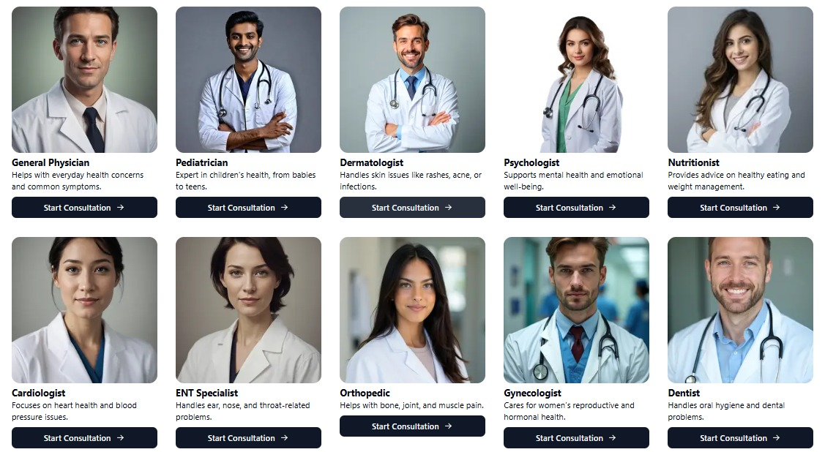
Fig 1: Website Interface Showing Medical Specialists

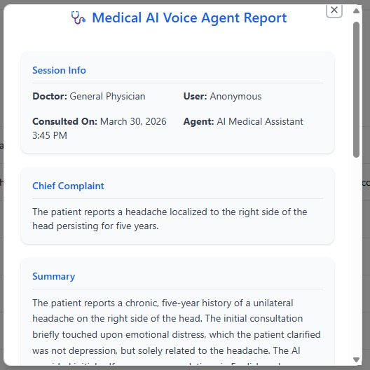
Fig 2: Describing the Symptoms
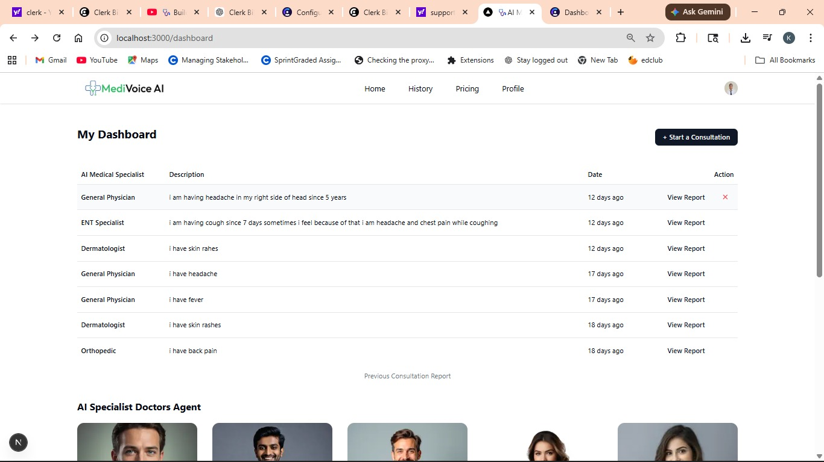
Fig 3: Report Generation Dashboard

The developed system includes an interactive and user-friendly interface designed to simplify healthcare interaction. The dashboard allows users to view previous consultations, initiate new sessions, and access generated medical reports. Users can select different medical specialists such as general physicians, dermatologists, or cardiologists based on their symptoms.
The consultation history module maintains records of previous interactions, enabling users to revisit reports and track their health conditions over time. The report interface presents structured outputs, including session information, chief complaints, and summaries generated by the AI system. This structured presentation improves readability and assists users in understanding their health conditions more effectively.

3. PROPOSED METHODOLOGY
The proposed methodology integrates voice processing, natural language understanding, and AI reasoning into a unified system. The process begins when the user initiates a consultation session and provides voice input describing their symptoms. The speech input is converted into text using AssemblyAI, ensuring accurate transcription.
The transcribed data is then processed using natural language processing techniques to extract key medical entities such as symptoms, duration, and severity. The AI reasoning engine analyzes this information and generates insights, including possible conditions and recommendations. The system then organizes the output into a structured medical report, which is displayed to the user and stored in the database for future reference.
Security and authentication are handled using Clerk, ensuring that only authorized users can access their medical data. The use of Neon DB enables scalable and secure storage of user information and reports.

4. SYSTEM WORKFLOW
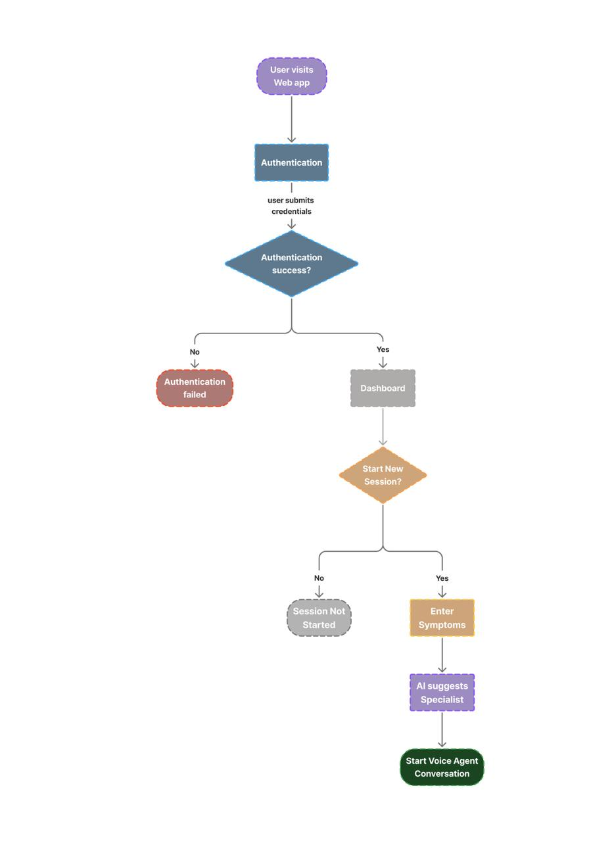
Fig 4: System workflow
The system workflow follows a structured sequence of operations that ensures smooth interaction and real-time processing. Initially, the user accesses the web application and completes the authentication process. Upon successful login, the user is redirected to the dashboard, where they can either start a new consultation or view previous records.
If a new session is initiated, the user enters symptoms through voice input. The system processes the input and suggests an appropriate medical specialist based on the analysis. Following this, the AI voice agent initiates a conversation to gather additional details. The processed data is then used to generate a medical report, which is displayed to the user and stored securely.
This workflow ensures efficient data processing, seamless user experience, and accurate report generation.

5. SYSTEM ARCHITECTURE
The system is designed using a modular architecture that separates the frontend, backend, and processing components. The frontend, developed using Next.js and React, provides a responsive interface for user interaction. The backend handles API requests and integrates AI processing functionalities.
The speech recognition module converts voice input into text, while the NLP module extracts meaningful information from the text. The AI engine processes this information to generate insights and recommendations. The database layer stores user data and reports securely, while the authentication layer ensures secure access control. This architecture enables scalability, maintainability, and efficient performance.

6. IMPLEMENTATION
The implementation involves integrating multiple technologies to create a seamless system. The frontend interface includes components for voice input, report viewing, and dashboard management. The backend processes user requests and communicates with external APIs for speech recognition and AI processing.
The system supports multiple consultations, allowing users to interact with different specialists. The generated reports include structured sections such as session information, chief complaints, and summaries. These reports are stored in the database and can be accessed through the dashboard.
The integration of real-time processing ensures that users receive immediate feedback, enhancing the overall experience.

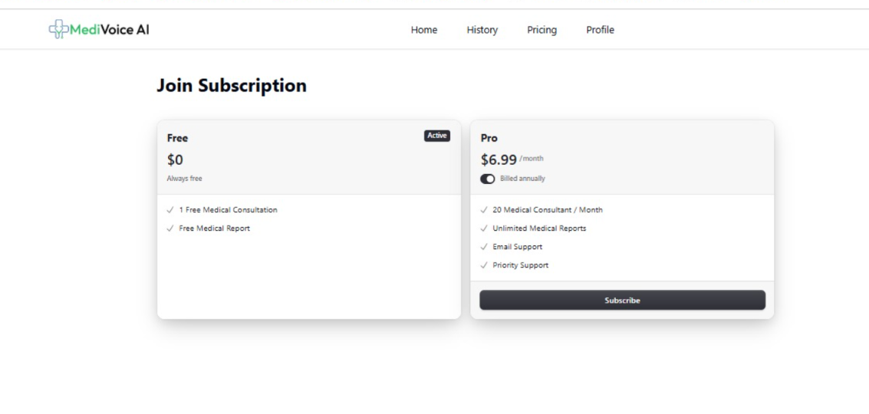
Fig 5: Subscription Model Interface Showing Free and Pro Plans

The system incorporates a subscription-based model to enhance functionality and scalability. As shown in Fig. 5, users can choose between a free plan and a premium plan. The free plan provides basic features such as limited medical consultations and report access, while the pro plan offers advanced features including multiple consultations per month, unlimited report generation, and priority support. This model enables efficient resource management and provides flexibility based on user requirements.

7. PERFORMANCE EVALUATION
The proposed system is evaluated using real-time API responses and user interaction testing rather than a pre-trained dataset. The performance of the system is measured using metrics such as response time, API reliability, and speech recognition accuracy.
The response time of the system is calculated as:
Response Time = T_output − T_input
The reliability of the system is evaluated using API success rate, calculated as:
Success Rate = Successful Requests / Total Requests
The speech recognition accuracy is evaluated as:
Accuracy = (Correct Transcriptions / Total Inputs) × 100

8. RESULTS
The system was evaluated based on performance, usability, and accuracy. The speech recognition module demonstrated high accuracy in converting voice input into text, while the NLP and AI components effectively analyzed symptoms and generated meaningful insights.
The system achieved an average response time of 2–4 seconds, enabling real-time interaction. The API success rate was measured between 95% and 98%, demonstrating high reliability. Additionally, the speech recognition module achieved an accuracy of approximately 90% under standard conditions.

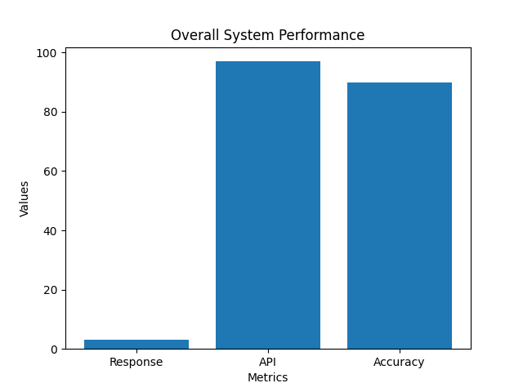
Fig 6: Overall System Performance Comparison
The dashboard and report interfaces improved user engagement by providing clear and structured information. The results indicate that the system performs efficiently in real-time scenarios. The low response time ensures seamless user interaction, while the high API success rate confirms system stability.
Although speech recognition accuracy may vary slightly due to noise and speech variations, it remains sufficiently reliable for practical use. Compared to traditional healthcare systems that rely on manual input, the proposed system significantly reduces user effort and enhances accessibility through voice-based interaction.
Overall, the implementation demonstrated improved efficiency, reduced manual effort, and enhanced accessibility compared to traditional systems.

9. CONCLUSION
The proposed AI-powered medical voice agent successfully integrates voice recognition, natural language processing, and modern web technologies to create an efficient healthcare solution. The system enhances accessibility, reduces manual effort, and provides real-time medical insights.
By incorporating features such as consultation history, specialist selection, and automated report generation, the application offers a comprehensive healthcare experience. Future improvements may include multilingual support, advanced AI models, and integration with healthcare systems, further enhancing its capabilities.
The inclusion of a subscription-based model further improves the practical applicability and scalability of the system, making it suitable for real-world deployment.

REFERENCES
[1] Rekha P., Buddesab, Shruthi K., Sathya M., Nanda Ashwin. “Tabib: Chatbot for Healthcare Automation with Audio Assistance using Artificial Intelligence,” International Research Journal on Advanced Science Hub, Vol. 5 No. 05 (May 2023). rspsciencehub.com
[2] Yuvanshu Maini, Abhishek Jha, Prateek Garg, Dr. Jyoti Sharma. “NORA – HealthCare Voice Based Chatbot,” IJRASET Journal for Research in Applied Science and Engineering Technology, DOI:10.22214/ijraset.2023.48660 (2023). IJRASET
[3] S. K. Sydulu, Koppula Naga Jyothi, Pavuluri Naga Chandana, Katru Vijaya Sree Enosh, Pallapu Gopi. “Voice and Text-Based Healthcare Chatbot with Real-Time Multilingual Translation,” International Journal of Recent Advances in Engineering and Technology, Vol. 14 No. 1 (2025), pp. 36-43. journals.mriindia.com
[4] Arun Babu, Sekhar Babu Boddu. “BERT-Based Medical Chatbot: Enhancing Healthcare Communication through Natural Language Understanding,” Exploratory Research in Clinical and Social Pharmacy, 2024. DOI:10.1016/j.rcsop.2024.100419. PubMed+1
[5] Namrata Mohite, Dhanashri Bankar, Amit Bhosale. “Voice Chat Bot in Healthcare System,” International Journal of Innovations in Engineering Research and Technology, July 2023. repo.ijiert.org
[6] Ke Liang, Sifan Wu, Jiayi Gu. “MKA: A Scalable Medical Knowledge Assisted Mechanism for Generative Models on Medical Conversation Tasks,” arXiv preprint (Dec 2023). arXiv
[7] Rahul Kumar Singh, Sakshi Kathuria, Pankaj Saraswat, Ashok Kumar. “Enhancing Voice Assistant Systems through Advanced AI and NLP Techniques,” Journal of Recent Innovations in Computer Science and Technology, DOI:10.70454/JRICST.2025.20110 (2025). jricst.com

